If you live, work or play in Deepcut, it’s time to tell us what you want for the future

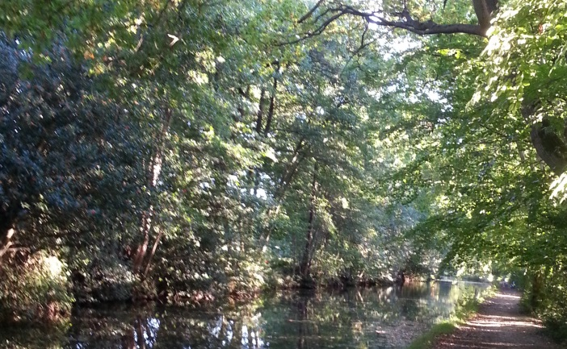
Deepcut Neighbourhood Forum Consultation: March 2016

Please complete this questionnaire and return it to: stakeholdersconsultation@deepcutforum.org.uk or 12 Crofters Close, Deepcut, Camberley, GU16 6GH by the end of April

Key stakeholder Questionnaire
We are consulting key organisations which operate in the Deepcut area to discover what your current activities are and what your plans for the next 5-10 years will be. Please tell us what you value about Deepcut and want to see preserved and what you’d like to see improved – and how. What role will your organisation play in local affairs and how could the Neighbourhood Plan dovetail with your own strategies and programmes for the area?

How many people do you employ in or around Deepcut

What does your organisation do now and what are its plans for the next 5 – 10 years

What issues or concerns would you like to see covered in the Neighbourhood Plan

What comments would you like to make about the following aspects of local life

The woods and the open green spaces

Creating a village heart for Deepcut

The services and facilities needed by residents and organisations in Deepcut

Traffic management, parking and transport issues for your organisation

How should business and enterprise be developed in the future

Protection of the character of this area and the environment

Any other issues you’d like to mention or comments you’d like to make

We will need to demonstrate in the Neighbourhood Plan that we have consulted you and obtained your input. We will also want to feed back to you later. So please give us your name and some contact details so we can let you know what happens:
Name: Your role in the organisation
Name of organisation:
Postal address Your email address:

Please return this completed form to ……. By [date] Thank you for your help.

