If you live, work or play in Deepcut, it’s time to tell us what you want for the future

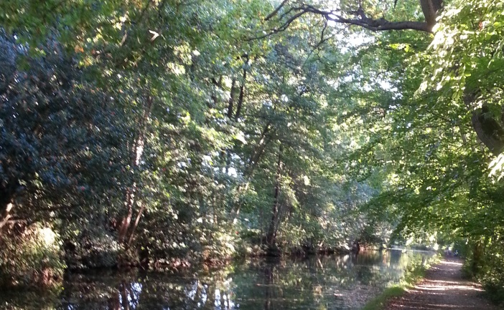
Deepcut Neighbourhood Forum Consultation: February 2016

Please complete this questionnaire and return it to: stakeholdersconsultation@deepcutforum.org.uk or 12 Crofters Close, Deepcut, Camberley, GU16 6GH by the end of April

Resident Questionnaire
Don’t feel the need to complete every section. If there’s a subject on which you don’t have strong views, please just ignore it and move on to one on which you do have clear opinions. Please tell us what you love about Deepcut and want to see preserved and what you’d like to see improved – and how. What do we need here over the next 5 – 10 years….

The woods and the open green spaces

A heart for our village

The services and facilities we need or want here

Traffic management, parking and transport

Business and enterprise development

Protection of the character of this area and the environment

Any other issues you’d like to mention or comments you’d like to make

We will need to demonstrate in the Neighbourhood Plan that we have consulted you and obtained your input. We will also want to feed back to you later. So please give us your name and some contact details so we can let you know what happens:

Name:
Postal address / email address:

Delete as appropriate: I live in Deepcut / I work in Deepcut / I regularly visit Deepcut

