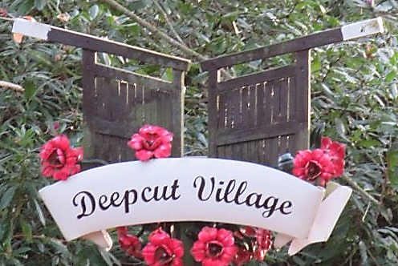
DEEPCUT
NEIGHBOURHOOD FORUM

MEMBERSHIP FORM

Print Name
Address
Postcode
Email Address
Telephone |  | MOBILE
Are you an existing member of the DNF? |  |  | YES |  | NO
Would you like to join the DNF? |  |  | YES |  | NO
Do you live in Deepcut? |  |  | YES |  | NO
Do you work in Deepcut? |  |  | YES |  | NO
Are you a local Councillor? |  |  | YES |  | NO
Optional Classification

Ethnicity | White | Black | Asian | Other
Gender | Female | Male | Other | Do you have a disability?
Age | 0 -16 | 17 -24 | 25 -39 | 40 -64 | 65+

How YOU can help with the Deepcut Neighbourhood Plan:
Relevant skills
(e.g. IT, Planning, Admin)
Area of interest
(e.g. Environment, Transport, Trees)
Working Party/Group | DNF Committee  Environmental Working Party  Housing Working Party  Transport Working Party  Business & Retail Working Party  Leaflet Distribution/Events Support
Please return to: secretary@deepcutforum.org.uk or 43 Stickle Down, Deepcut GU16 6GB

NEIGHBOURHOOD PLAN KEY ISSUES – PRIORITY (10 High, 1 Low)

 | AREA | COMMENT | PRIORITY
A | ENVIRONMENT
B | HOUSING
C | TRAFFIC/TRANSPORT
D | BUSINESS
E | RETAIL
F | PARKING
G | HERITAGE
H | SUSTAINABILITY
I | HOME-WORKING
J | COMMUNICATIONS
OTHER PLEASE LIST BELOW

Deepcut Designated Area is as approved & validated by SHBC.
Map on website: www.deepcutforum.org.uk
Any other comments:
Please return to: secretary@deepcutforum.org.uk or 43 Stickle Down, Deepcut GU16 6GB

