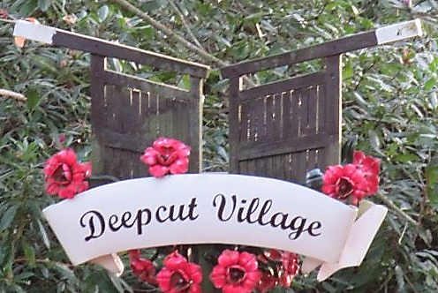
The DEEPCUT NEIGHBOURHOOD FORUM (www.deepcutforum.org.uk) is working with LOCALITY (www.locality.org.uk) to prepare the framework for the DEEPCUT NEIGHBOURHOOD PLAN.
CONSULTATION

The overall aim of the DEEPCUT NEIGHBOURHOOD PLAN is to shape and enhance Deepcut and surrounding area and to improve opportunities and quality of life for all and to create a more prosperous local economy.

The DEEPCUT NEIGHBOURHOOD PLAN must have a robust programme of community engagement and be based on the views and aspirations and needs of the local people including Mindenhurst, local stakeholder groups and businesses.to identify key issues to inform the visions and aims of the community.

Over the years, there have been a number of opportunities for local people to comment on their vision for Deepcut and wish to engage once more with you to ensure that the Plan accurately reflects residents and local businesses views. Your comments on the questions posed below would be very welcome.:

- What is good about the area?
- What is bad about the area?
- What makes a neighbourhood good to live and work in?
- What pressures affect the area now and in the future?
- What needs to change?
Feel free to download this document and respond to the all/some of the questions.
Please send you responses to: secretary@deepcutforum.org.uk

Contact details:
NAME
ADDRESS
EMAIL

OR fill in the reverse of this sheet and place in the post box of any of the following:
Deepcut Village Centre, Deepcut Garage, 43 Stickle Down, Dettingen Park GU16 6GB
or photograph/scan & email to: secretary@deepcutforum.org.uk
**********************************************************************************
COVID times have limited the ways in which the Forum can communicate with the community to essentially ZOOM Meetings and Leaflet distribution and feedback. Announcements of Zoom meetings and draft policies for residents and local businesses to comment upon will go up on the website.

For convenience, however, if you would like to complete the Membership Form on this website or the contact information above, it will enable us to email you directly with relevant consultation information.

The Forum would be delighted to have more residents or volunteer consultants join to help with consultation, drafting the aims, objectives and policies and preparing for submission to Surrey Heath.
We meet fortnightly, currently by Zoom, and are working towards finalising the Plan in 2021.

If you would like to join the Forum and have a particular interest to bring to the plan such as sustainability,
environmental issues, business, retail, transport or heritage, please email our secretary on: secretary@deepcutforum.org.uk or phone on 01252 836664
PLEASE RESPOND, IF POSSIBLE, WITHIN 28 DAYS OF RECEIPT OF THIS FLYER

CONSULTATION
FEEDBACK FORM

What is good about the area?

What is bad about the area?

What makes a neighbourhood good to live and work in?

What pressures affect the area now and in the future?

What needs to change?

Place completed forms in the post box of any of the following:
Deepcut Village Centre, Deepcut Garage, 43 Stickle Down, Dettingen Park GU16 6GB
or photograph/scan & email to: secretary@deepcutforum.org.uk
PLEASE RESPOND, IF POSSIBLE, WITHIN 28 DAYS OF RECEIPT OF THIS FLYER

