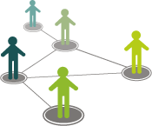
Deepcut Neighbourhood Development Plan

June 2015

Consultation Strategy

Contents

- Aim for ongoing programme of public engagement
- Vision and objectives for Plan
3.0 Demographics
4.0 Accessibility
5.0 Methods for communicating/ publicising events/ activities
6.0 Overview of possible engagement activities
7.0 Next steps and Working Groups
8.0 Diary of events

Introduction
The village of Deepcut mostly lies within the borough of Surrey Heath, although a small part lies in the Borough of Guildford. The Princess Royal Barracks, and various associated but physically separated facilities such as the Officers’ Mess, lie within Deepcut. Our Neighbourhood Area excludes the area covered by the Collective phrase “The Princess Royal Barracks” as used in progressing and securing an Outline Planning Agreement in July 2013 and also that part of Deepcut lying in the Borough of Guildford.
The DNF’s area is multi-faceted and can be broken up into separate parcels. Nature has created relatively high and low lying areas. Man has created transport related facilities that cut through the Area creating artificial divisions of land running both east-west and north-south.
Within the DNF Area there is a relatively high area to the North which is home to:
- The recently constructed residential settlement known as Alma-Dettingen
- Mature military related housing in the Aisne Road, Brunswick Road, Dettingen Road, and Alma Gardens areas.
- Recreational facilities controlled by the Frimley Fuel Allotments Charity including an area subject to a long lease to the Pine Ridge Golf Club.
- Areas that are subject to certain environmental designations including a Special Protection Area (SPA), and its associated Buffer Zone, and a Site of Nature Conservation Importance (SNCI) which is used by the Army.
Moving in a southerly direction the land falls relatively gently before rising again. At the low point, Deepcut is crossed by 3 pieces of infra-structure that all run East-West. Sequentially from north to south these are
- The Basingstoke Canal
- The 4 track rail link between London and the South West through Basingstoke.
- The B 3012 Guildford Road which links Deepcut to the Guildford and Woking areas to the East and Frimley Green to the West.
The initial Deepcut settlement was largely in the area between the high ground to the North and the Basingstoke Canal although some housing exists between both the Canal and the Railway and also adjacent to Guildford Road. Whilst supplemented by some infill along minor roads, the earlier Deepcut settlement has largely followed a “ribbon” development pattern along the North-South aligned Deepcut Bridge Road, along Lake Road, which runs in a south-westerly direction towards Frimley Green, and finally along the joined private roads of Bellew and Blackdown Roads that complete a triangle.
Although the lower lying part of Deepcut contains the core of the established residential properties it also contains significant areas of Environmental importance. These are:
- The area immediately adjacent to the Basingstoke Canal is a Site of Special Scientific Importance (SSSI).
- A Special Protection Area (SPA) with an associated SPA Buffer Zone.
- Countryside Beyond the Green Belt
- A Site of Nature Conservation Importance (SNCI).
The DNF’s Area falls within Surrey Heath Borough. Our Borough is recognised as one of the most densely covered by trees in the whole of the UK. Our Neighbourhood Forum Area contributes massively to that, particularly our western section which is recognised as forming a “Green Lung”. Trees form an ever-present part of the landscape. In addition there is much heathland habitat within the Area that supports wildlife and, where not protected, these provide essential recreational opportunities whilst the Area’s topography lends itself to varying vistas. Together the combination of varying natural features and vegetation and a small population creates the feel of a rural village.

Aims
The aim of public Engagement is to gather residents’ ideas and wishes for the future of Deepcut. A series of public engagements to create a Deepcut NDP will be launched in July 2015

The events are designed to create a transparent and open process, which both supports and involves from the outset the local community and other interested parties in shaping the future of Deepcut within the NDP area.

Engagement will ensure Deepcut NDP will be an evidence-based document with a clear audit trail of activities and outcomes. The background evidence for the document is to be gathered through focused community engagement reaching the widest audience possible: both within the NDP area and other people within representative groups that might naturally form part of a larger community.

Vision and objectives
Deepcut Neighbourhood Forum’s Mission:
To secure approval for, and implementation of, a Neighbourhood Plan that protects and enhances Deepcut’s landscape, its village character, and the residents’ quality of life.

The Neighbourhood Plan’s Vision:
An improved Deepcut, sustaining its rural village feel, typified by its heathland, woodland and open spaces, whilst simultaneously possessing an enhanced vibrant community spirit amongst its people. Residents have the responsibility to protect, and the freedom to enjoy, the village’s bio-diversity, wildlife, and its trees, flora and fauna.
Sustaining Deepcut’s physical separateness from the surrounding urban areas will involve protecting and safe-guarding its countryside. Closer links with the adjacent urban areas will be sought through the development of sustainable, environmentally friendly, walking and cycling networks and the provision of greater Public Transport.
Increased employment opportunities will be sought based upon enhanced desirable retail/ commercial facilities and improved home working capabilities.
Residents’ quality of life in Deepcut will be further improved by providing more local access to essential services including Medical, Educational, and Financial along with the provision of improved recreational and community facilities. In many of these cases this will involve close co-operation with those responsible for the redevelopment of the PRB site.

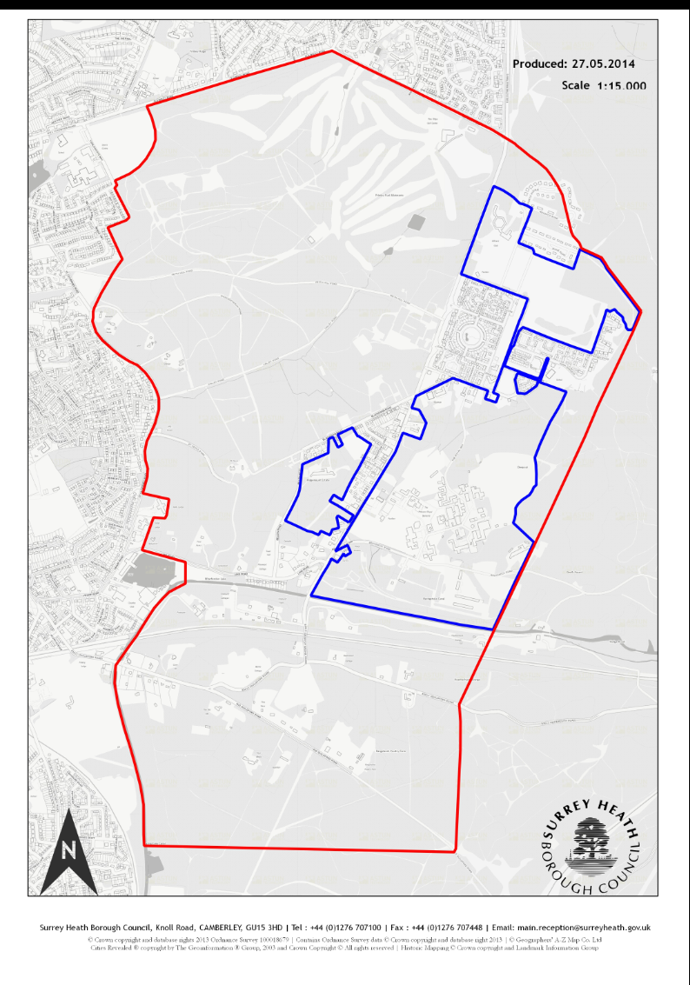

3.0 Demographic information for the area
The population of Deepcut as a whole is 2,477 living in 803 households at the time of the 2011 Census of which 61.1% were in very good health and 3% of the population were unemployed. Reflecting a slight gender skew in the main sector of employment at the Princess Royal Barracks (as female longevity was higher than male longevity at the time of the census) 1,296 of the population were men, the remaining 1,181 were women.

Ethnicity | Deepcut | Surrey Heath | South East | England
White: English/Welsh/Scottish/Northern Irish/British | 82.3 | 84.9 | 85.2 | 79.8
Asian/Asian British: Other Asian | 4.1 | 2.5 | 1.4 | 1.5
Black/African/Caribbean/Black British; African | 1.9 | 0.6 | 1.0 | 1.8
Other Ethnic Group; Any Other Ethnic Group | 1.4 | 0.5 | 0.4 | 0.6
Asian/Asian British: Indian (Persons) | 1.5 | 2.0 | 1.8 | 2.6

4.0 Accessibility
A major factor in the development of a Neighbourhood Development Plan is giving and receiving information with your community. There are a number different methods to communicate and most will rely on the written word. The aim is to maximise on the effectiveness of all communications so make sure your material is easily understood, legible and accessible.

Don’t give anyone the excuse to opt out of the process because your message is too difficult to read or understand.

To market information or an event where possible:

- Use clear simple language
- Use short sentences
- Avoid jargon – or explain what it means
- Use photos, drawings and symbols to support text

Text must use:

- Use a san serif font e.g. Verdana, Arial, Trebuchet MS, Tahoma etc
- Minimum text size 12
- Use left hand justification
- Used mixed upper and lower case – easier to read than all upper case
- Use Style drop down menu for headings and titles for people using assisted technology
- Good contrast between text and background

Text must not use:

- simulated handwriting and ornate typefaces
- italics – use bold instead to emphasise
- text over images it is difficult to read
- Use vertical text – difficult to read
- Underlining - use bold instead to emphasise
- Shiny paper – matt is easier to read from

For more hints and tips on creating clear print and web accessibility see RNIB See it Right and AbilityNet. It gives details about creating accessible information in many formats.

Ensure that website meets WC3 accessibility guidelines and converts to tablet and mobile devices.

5.0 Methods of communicating all engagement events
Ensure that evidence of all participants is captured at each event to provide proof of community inclusion. This will contribute to your accountability at the Examination stage of the Plan and on into the subsequent implementation by the Planning Department.

Gather information on:

- Who participated
- When they participated / at which intervention
- Where they live
- Equality information Age, gender, disability, race etc
- Recruiting for role or keeping in contact

By recording who has been engaged you can take steps to engage with the people or groups who are missing so providing an audit trail of reaching a diverse community.

Record of numbers and salient points from each intervention can be recorded on the website. We asked……….., you said………… this can then be used in evidence for how the Plan is shaped.

Tips before undertaking an activity

Audience Make sure that the activity is targeted appropriately. Be clear about why you are engaging with the public, both in your own mind and in your communication with participants. Have clear objectives on what you want to achieve and methods of achieving this.

Do not raise unrealistic expectations amongst participants – some boundaries around what an NDP can and cannot achieve.

Planning It takes time to organise activities – particularly event based ones. Write a realistic project plan and add in some contingency time. Make sure you have enough helpers.

Venue a community venue can sometimes be more welcoming for your audience. Is the venue easily accessible and free to enter? Is it a location people visit on a regular basis? Are the acoustics important?

Comfort Toilets, refreshments, heating...sounds obvious but easy to overlook

Access From wheelchair access to parking, hearing and seeing – it’s important to ensure that people can easily engage with your event. Help make people feel significant to the process.

Content What type of activity are you going to do and how are you going to ensure that it is relevant to your chosen audience? Remember that your audience will involve people with different learning styles so try to ensure you use alternative ways to present the content.

Web and Social Media

- Designated DCNDP website with links to social media
- Facebook / Twitter

The designated website will be the first stop for information gathering and dissemination. Interested parties will be able to gain information on the progress of the Plan and feedback from events and surveys. It will be relatively static so social media can sit alongside the website to give day to day views; conversation; awareness raising.

These forms of digital marketing will allow the public to know, like and trust the DNDP process and the people leading it.

Email
- Email contact list from engagement events
- Local interest groups
- Surrey Heath Residents Network
- Churches and wider faith community
- Local businesses
- School /s

Developing a database of interested parties to keep them informed of events and progress.

Printed Leaflets/posters
- Noticeboards within and near Deepcut
- Community Centre
- Post Offices
- Word of mouth
- Local area / street champions

These can be used for general awareness raising and for specific events. It can also signpost people to the website and social media for more information.

6.0 Overview of other possible engagement activities

- Community-led survey of the character of the NDP area and its setting within the landscape
- Survey of the location and type of businesses and other facilities in the NDP area
- Survey of what routes people use within the NDP area (from where, to where)
- Information provided to local services and groups
- Future thinking about the NDP area
- Figuregrounds to show change over time

7.0 Next Steps and Working Groups
NDP reporting structure and working groups need to be established. The next steps will include seeking members, defining activities and reporting procedures.

Steering Group
- Conduct skills analysis
- Appoint to various roles
- Adopt Terms of Reference
- Establish / market test Vision and Aims

Public Engagement
- Agree timetable and methods of engagement
- Set objectives for launch to shape content of event
- Establish topic / theme groups and recruit members

Project Plan
- Agree Deepcuts delivery and timescales from Project Framework
- Assign leads to specific tasks

8.0 Diary of events and activities – to be confirmed and developed with Deepcut NDP
Date | Event | Location | Intention | Lead
4th July | Royal Logistics Corp Open Day | Dettingen Fields, Deepcut | Advertise Launch Event | Steering Group
?? July/ September | Launch of Deepcut NDP | Deepcut Community Centre | Raise awareness of NDP & recruit volunteers | Steering Group
 |  |  | Presentation of draft Plan
 |  |  | Submission of Plan
?? 2016 |  |  | Adoption of Plan

